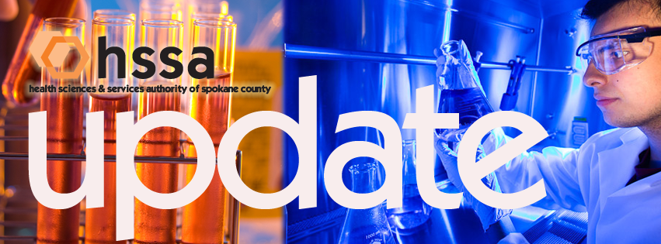

Grant Proposal Grant-Writing Consultation: Small Business

Intent:
To assist start-up small businesses seeking SBIR/STTR grants from the federal government, NIH, NSF, etc., HSSA has established a grant to support up to $5,000 per year to fund professional grant-writing consultancy in order to improve the success rate or achieving SBIR/STTR grants, to establish a track record for local health sciences research and to develop a critical mass of research talent in Spokane County.
Eligibility:
Any small business that has completed basic research on a therapy, drug, device or practice that meets a compelling unmet need. The grantee also should have conducted a preliminary market study, and discussed the project with potential users, sought preliminary patents, or filed provisional patents. A feasibility analysis should be on file and the company officially formed. This is the point in the company’s life that it desires federal SBIR/STTR funding to move through the concept stage and to establish proof of concept. The business must be located in Spokane County.
Funding:
HSSA will provide up to $5,000 which will be paid directly to a grant-writing consultant selected by the applicant. This is an open grant and may be applied for at any time.

Grant Proposal Grant-Writing Consultation: Academic Laboratories

Intent:
To increase the success rate of academic laboratories in Spokane County in receiving multi-year funding for health- and life-sciences-related research. Increased success will assist in establishing a track record for local health sciences research, will support the development of critical mass of talent in this sector, and will contribute to generating an educated technical workforce that will be attractive to companies considering relocating to Spokane County.
Eligibility:
Any faculty member from Spokane county universities who is resubmitting a proposal for a multi-year project. Specifically, 1) the project must be focused on a health- or life-science issue; 2) the project must be multi-year in nature (minimum two years, three-to-five year projects preferred); 3) the grant budget must be substantial (minimum of $250,000 per year in total costs); 4) the application must have been submitted in a previous round and deemed “acceptable” (in NIH terms, “scored), but not funded; and 5) the applicant must be able to articulate what novel intellectual property, potentially leading to a commercializable product, process or services, will be generated by the project.
Funding:
HSSA will provide up to $5,000 which will be paid directly to a grant-writing consultant selected by the applicant. This is an open grant and may be applied for at any time.

How to Apply for a Small Business or Academic Laboratories
Grant-Writing Assistant Grant

Send a Letter of Interest (LOI) outlining your research and answering the appropriate eligibility criteria as defined above to the Health Sciences & Services Authority (HSSA), McKinstry Innovation Center, 850 E. Spokane Falls Boulevard, Spokane, WA 99202 or email the letter to susan@hssaspokane.org. If your proposal is selected for this grant, the grantee will interview a group of pre-qualified (by HSSA) grant-writing consultants and chose one with whom to work. HSSA will contract with the grant-writing consultant selected by the grantee and will directly reimburse the consultant for his/her services to the grantee.

About Our Board:
Nancy Isserlis, City Attorney, City of Spokane, and HSSA Board Chair; Michael Wilson, Consultant and Former Chief Executive, Providence Health Care, Grants Committee Chair; Olú Ekúndayò, MD, MPH, DrPH, Associate Professor & Research Director, MPH Program, Eastern Washington University; Jason Thackston, Senior Vice President of Energy Resources, Avista Corp., Finance Committee Chair; Dr. Dean Martz, Chief Medical Officer, Providence Urban Hospitals; Kevin Oldenburg, Founder, Ph.D., 2nd Sight Bioscience; Gary Pollack, Ph.D., Dean, WSU College of Pharmacy; David J. Vachon, Ph.D., CEO/Founder, Iasis Molecular Sciences/Novion Technologies, and Francisco R. Velàzquez, M.D., S.M., President & CEO, PAML.

For More Information: The mission of HSSA is to invest funds to create and support a nationally competitive health sciences research cluster in Spokane County, and to increase access to health care. HSSA works collaboratively with community partners to catalyze higher education research and the health sciences industry to lead to higher wage jobs, long-term sustainability and economic diversification. For more information, visit our website at www.hssaspokane.org, or contact Susan Ashe, Executive Director, at 509.483.5985 or info@hssaspokane.org.

