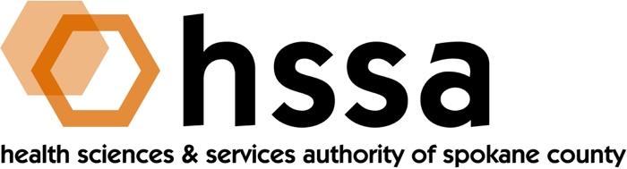

HSSA BOARD MEETING
Wednesday, May 16, 2018 3–5 PM
Gonzaga University, Hemmingson Center, LaStorta Room 211

AGENDA

- Call to Order – Nancy Isserlis, Board Chair (05 min.)
- Introductions
- Establish Quorum, Confirm Agenda

2) Board Action –Nancy Isserlis
- Approve February 21, 2018 Meeting Minutes Action Required
- Approve February 21, 2018 Board Retreat Minutes Action Required
- Approve HSSA Resolution 2018-1 (with new signatures Action Required
Board members for County Treasurer)
- Approve Research Grants Funding, Add New Category Action Required
as determined at meeting

- Chair’s Report—Nancy Isserlis (35 min.)
- Approve February 21, 2018 Meeting Minutes
- Warrants paid report
- Spokane County Morgue
- Other Business
  - Presentation by Lynx Healthcare
  - Comments by Dave Vachon

- Executive Director’s Report (In packet)

- Finance Committee Report – Jason Thackston

- Grants Committee Report – Mike Wilson
- Discussion of Strategic Grants Discussion
  - Human Capital & Infrastructure
  - Small Business Matching SBIR/STTR Grants
  - Health Delivery/Translational Research
  - Small Grant Writing Assistance
  - Access to Care
  - Capital Investment/Spending

- Legal Report

- Executive Committee (if necessary)

- Other Business

- Adjournment

The next meeting of the HSSA Board is September 19, 2018, Location TBD.

