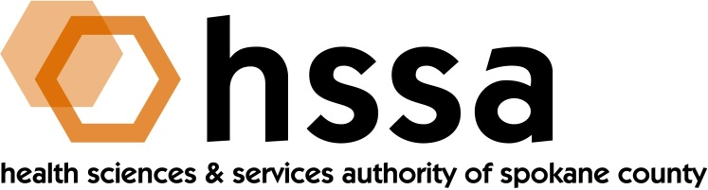

HSSA BOARD OF DIRECTORS
Minutes of the June 19, 2019 Board Meeting
Gonzaga University, Goa Room, Hemmingson Center

Members Present: Nancy Isserlis, Board Chair; Mike Wilson, Grants Committee Chair; Jason Thackston, Finance Chair; Scott Gordon, Darryl Potyk, Dave Vachon, and Frank Velázquez

Members Absent: Kevin Oldenburg, Gary Pollack

Staff Present:
Susan Ashe, Executive Director; Laura McAloon, Attorney; Gaylene Lewin, Accountant

Guests:
There were no guests.

- Call to Order
Nancy Isserlis welcomed everyone and called the meeting to order at approximately 3 PM. The meeting was held at Gonzaga University, Hemmingson Center, Goa Room.

- Board Actions
- Frank Velázquez moved to approve to approve the minutes of the May 6, 2019 board meeting and Jason Thackston seconded the motion. The motion was unanimously passed.
- Mike Wilson moved and Jason Thackston seconded a motion to leave the Grant Award
Agreement (GAA) language as is and to ad payback language, plus add the friendly amendment to eliminate the Intellectial Propert (IP) language, which passed unanimously.
- Jason Thackston moved and Dave Vachon seconded a motion to change the reporting requirement to semiannual, which also passed unanimously.

Staff was instructed to develop GAA grant payback language and incorporate the above motions and schedule a Special Board meeting to review and take action.

- Chair’s Report
Nancy Isserlis reported that the Board Chair had signed a series of warrants since the Board last met and when a warrant required two signatures these were required, Board Member Dave Vachon provided it.

The Chair reported on the celebration at the MAC on May 23rd of the passage of legislation by the Washington State Legislature that extended the HSSA for 15 years. She thanked Frank Velázquez for arranging the venue and Susan Ashe for the arrangements. Sen. Andy Billig attended the event, along with about 35 people.

The Chair also reported that she attended the Life Science Washington East West Summit at the historic Davenport Hotel and thanked Susan for serving on the Planning Committee. The event theme was “Advancing Neuroscience in Eastern Washington” and speakers were excellent. Over 100 people attended.
- Executive Director’s Report
The Executive Director’s Report was included in the Board packet members received at the meeting.

- Committee Reports

- Finance Committee
Jason Thackston, Finance Committee Chair, provided the Finance Committee report. All looks good and HSSA overhead continues to remain below l0% threshold at 8.8%.
B. Grants Committee
Mike Wilson reported that a subcommittee of the Grants Committee met earlier in the week to discuss the existing Grant Award Agreement to provide language about future grant paybacks to be required. The Board had received in advance of the meeting changes made by Board Member Kevin Oldenburg, leader of the subcommittee. Wilson then turned the meeting over to the Board’s legal counsel to discuss the draft language. There was much discussion, and the Board asked counsel to provide a clean redraft of changes to be circulated prior to a Special Board Meeting to be arranged by staff the following week. The draft from which Counsel worked was the HSSA’s original draft. Counsel was asked to make three changes: 1) change Art 4 Progress Reports to be required “semi-annually” not quarterly; 2) delete Art. 6 regarding Intellectual Property, and 3) to restate the grant payback language in Art. 32 to reflect the Board’s desire to obtain a grant payback of 5% annually until the grant is paid back (not more than the original grant) and to begin after the grantee has achieved income defined by the IRS as taxable income.

- Counsel’s Report
Counsel Laura McAloon discussed her review of the draft changes to the HSSA’s original Grant Award Agreement (GAA) that had been provided to her before the Board meeting. Changes were crafted by a subcommittee of the Board’s Grant Committee, but after the discussion with Counsel over legal and fiduciary concern, a revised draft of the original Agreement would be completed by her and sent to Board members.

The next regularly scheduled meeting of the HSSA Board is scheduled September 18, 2019, 3 PM, at the John J. Hemmingson Center in the Goa Room at Gonzaga University.

There will be a Special Board Meeting in this next several days and details about that meeting will be published when they are known.

