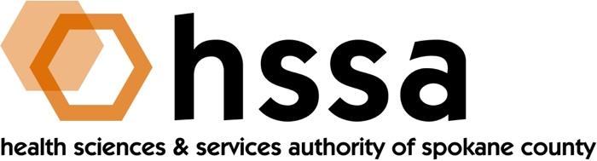

HSSA BOARD MEETING
Wednesday, December 19, 2018 3–5 PM
Ignite NW Technology Center, 120 N Pines

AGENDA

- Call to Order –Nancy Isserlis, Board Chair (05 min.)
- Establish Quorum, Confirm Agenda

- Action Items
- Approve Sept. 19, 2018 Meeting Minutes Action Required
- Approve Recommendations for Access to Care Annual Grant Action Required
- Approve Funding for Whitworth University Equipment as
Match to an NSF Grant Action Required
- Approve Providence Health Care Foundation Six-Month
Extension Request Action Required

- Approve HSSA By-Laws Housekeeping Updates Action Required
- Approve 2019 HSSA Board Meeting Dates Action Required

- Board Chair’s Report
- Approve Sept. 19, 2018 Meeting Minutes
- Defer Actions B & C above until Grants Report concluded
- Introduce Lars Gilberts, University District Executive Director
for an update on University District business and strategic plans
- Frank Velázquez to present about Life Science Washington Institute,
possible deployment to Spokane

- Executive Director’s Report (In packet)

- Finance Committee Report – Jason Thackston
- 2019 Budget Proposal

- Grants Committee Report – Mike Wilson
- 2019 Access to Care grant funding recommendations
- Whitworth University equipment funding recommendation for
Human Capital & Infrastructure matching grant - $148,866 – for a
Multi-user Single Crystal X –Ray Diffractometer (as matched by
a $375,000 NSF Major Research Instrumentation grant
- Capital Spending Fund Direction and Creation of Action Steps in anticipation of growth and lack of affordable incubator space for scientific startups
- Criteria clarification as to number of grants allowable from one investigator/researcher for Small Grant-Writing Support grants

- Legal Report – Laura McAloon
- Review By-Laws updates for approval

- Executive Committee (if necessary)

- Other Business

- Adjournment

The next meeting of the HSSA Board is March 20, 2019, Location TBD.

Proposed 2019 Meeting Dates (Quarterly, 3rd Wednesday, 3 PM)

March 20, 2019
June 19, 2019
September 18, 2019
December 18, 2019

