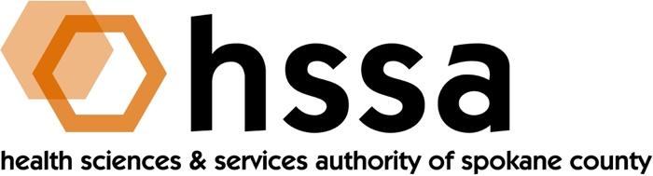

HSSA BOARD MEETING
Wednesday, September 19, 2018 3–5 PM
Gonzaga University, Hemmingson Center, Manresa Room 314A

AGENDA

- Call to Order –Nancy Isserlis, Board Chair (05 min.)

- Establish Quorum, Confirm Agenda
- Approve May 16, 2018 Meeting Minutes Action Required

- Action Items (no Chair Report) (35 min.)
- Approve May 16, 2018 Meeting Minutes
- Approve Issuance of annual Access to Care $300,000 grant

- Executive Director’s Report (In packet)

- Finance Committee Report – Jason Thackston

- Grants Committee Report – Mike Wilson

- Legal Report

- Executive Committee (if necessary)

- Other Business

- Adjournment

The next meeting of the HSSA Board is December 19, 2018, Location TBD.

