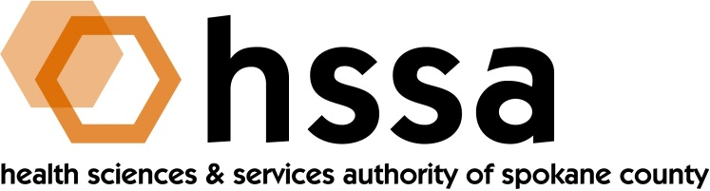

HSSA BOARD OF DIRECTORS
Minutes of the May 6, 2019 Board Meeting
Ignite NW Technology Center, 120 N Pine Street

Members Present: Nancy Isserlis, Board Chair; Mike Wilson, Grants Committee Chair; Jason Thackston, Finance Chair; Scott Gordon, Kevin Oldenburg, Gary Pollack, Darryl Potyk, Dave Vachon, and Frank Velázquez

Staff Present:
Susan Ashe, Executive Director

Guests:
There were no guests.

- Call to Order
Nancy Isserlis welcomed everyone and called the meeting to order at approximately 3 PM. The meeting was held at the Ignite Northwest Technology on the WSU Spokane campus.

- Board Actions
- Gary Pollack moved and Frank Velázquez seconded a motion to approve to approve both the December 19, 2018, and January 14, 2019 board meeting minutes. The motion was unanimously passed.
- Kevin Oldenburg moved and Gary Pollack seconded a motion to approve a $221,840 matching grant to Allele Diagnostics for its Congenital Heart Defects Rapid Results Diagnostics. The motion passed unanimously,
- Kevin Oldenburg moved and Gary Pollack seconded a motion to approve a $500,000 matching grant to Iasis Molecular Sciences for its CDMR Dept. or Army Catheter-Associated Urinary Tract Infections grant depending on detail provided by the grantee in its budget for $130,522 for overhead. The motion unanimously passed. David Vachon abstained from the vote.
- Kevin Oldenburg moved and Frank Velázquez seconded a motion to approve a $500,000 grant to the WSU College of Pharmacy to match a start-up package for Dr. Bhagwat Prasad. The motion unanimously passed. Gary Pollack abstained from the vote.

- Chair’s Report
Nancy Isserlis reported that the Board Chair had signed a series of warrants since the Board last met and when a warrant required two signatures these were required, Board Member Dave Vachon provided it.

The Chair announced the passage of legislation by the Washington State Legislature that extended the HSSA for 15 years. She attended and described the Governor’s signing of the bill, and she thanked Dave Vachon, Frank Velázquez and Susan Ashe for their support in Olympia. She announced that HSSA would celebrate passage of the legislation at a reception at the MAC on May 23rd and encouraged all Board members to attend.

- Executive Director’s Report
The Executive Director’s Report was included in the Board packet members received at the meeting.

- Committee Reports

- Finance Committee
Jason Thackston, Finance Committee Chair, provided the Finance Committee report. All looks good and HSSA overhead continues to remain below l0% threshold at 7.7%.
B. Grants Committee
Mike Wilson reported that the Grants Committee met earlier in the day. The Committee recommended for approval the following grant requests:
- Allele Diagnostic’s matching grant for $222,840
- Iasis Molecular Sciences matching grant for $500,000
- WSU College of Pharmacy’s start-up package for Dr. Bhagwat Prasad for $500,000

Mike also informed the Board that the Grants Committee had unanimously agreed to fund matching grants from sources other than SBIR/STTR grants, as long as those grants had been peer reviewed.

- Counsel’s Report
There was no report.

The next meeting of the HSSA Board is scheduled June 19, 2019, 3 PM, at the John J. Hemmingson Center in the Goa Room at Gonzaga University.

