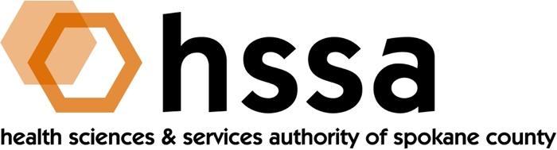

HSSA BOARD MEETING
Wednesday, December 18, 2019 - 3–5 PM
Gonzaga University, Goa Room #306 in Hemmingson Center

AGENDA

- Call to Order –Nancy Isserlis, Board Chair (05 min.)
- Establish Quorum, Confirm Agenda

- Action Items (10 min.)
- Approve September 18, 2019 Meeting Minutes Action Required
- Approve $300,000 2020 Access to Care Grants Action Required
(See attached)
- Approve 2nd Sight BioScience Automated Hop Stringing Action Required
Machine Matching $250,000 Grant
- Approve 3-month Agreement Extension for Spokane Action Required
Neighborhood Action Partners for its 2019 Access to Care
Grant “Collaborative Health Initiative”
- Discuss/Possible Action for Automated Contingency Management
System for the Reduction of Alcohol Use, Managed Health
Connections LLC $215,000 Matching Grant

- Board Chair’s Report (05 min.)
- Approve September 18, 2019 Board Meeting Minutes
- Board Chair’s Report

- Executive Director’s Report (In packet) (05 min.)

- Finance Committee Report – Jason Thackston (15 min.)
- Financials Update
- 2020 Budget
- Grants Committee Report – Mike Wilson (20 min.)
- Request approval of recommendations for 2020 Access to Care grants
- Request approval of 2nd Sight BioScience matching
$250,000 grant for “Automated Hop Stringing” to prevent human injury
- Request approval of a three-month extension for Spokane Neighborhood Action Partners for its 2019 Access to Care grant “Collaborative Health Initiative”
- Discussion of matching grant that was not discussed at the Grants Committee’s Nov. 21st meeting.
- Other grant-related discussion
- Grant Award Agreement Conclusion

- Legal Report – Laura McAloon

- Executive Committee (if necessary)

- Other Business

- Adjournment

The next meeting of the HSSA Board is March 18, 2020. Meeting location is to be determined.

###

