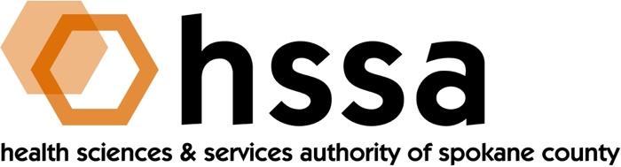

HSSA BOARD MEETING
Wednesday, June 19, 2019 3–5 PM
Gonzaga University, Goa Room in Hemmingson Center

AGENDA

- Call to Order –Nancy Isserlis, Board Chair (05 min.)
- Establish Quorum, Confirm Agenda

- Action Items
- Approve May 6, 2019 Meeting Minutes Action Required
- Approve “Payback Language” for Grant Agreements Action Required
- Other

- Board Chair’s Report
- Approve May 6, 2019 Board Meeting Minutes
- Board Chair’s Report

- Executive Director’s Report (In packet)

- Finance Committee Report – Jason Thackston
- Financials Update
- Grants Committee Report – Mike Wilson
- Discuss legal language recommendation(s) for a payback clause for HSSA Grant Award Agreements

- Legal Report – Laura McAloon

- Executive Committee (if necessary)

- Other Business

- Adjournment

The next meeting of the HSSA Board is September 18, 2019, Gonzaga University, Hemmingson Center, Goa Room.
###

