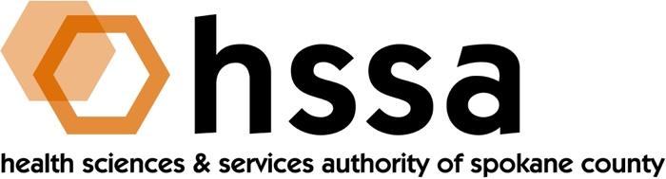

SPECIAL HSSA BOARD MEETING
Monday, May 6, 2019 3–5 PM
Ignite NW Technology Center

AGENDA

- Call to Order –Nancy Isserlis, Board Chair (05 min.)
- Establish Quorum, Confirm Agenda

- Action Items
- Approve December 19, 2018 Meeting Minutes Action Required
- Approve January 14, 2019 Special Meeting Minutes Action Required
- Approve Allele Diagnostics Matching SBIR/STTR
Grant for $222,840 Action Required
- Approve other recommendations from Grants Committee Action Required

- Board Chair’s Report
- Approve December 19, 2018, and January 24, 2019 Meeting Minutes
- Defer Action C and/or other grant requests above until Grants Report concluded
- Board Chair’s Report

- Executive Director’s Report (In packet)

- Finance Committee Report – Jason Thackston
- Financials Update
- Grants Committee Report – Mike Wilson
- January 14, 2019 Grants Committee Report
- Discuss policy recommendations from Committee on $1 million maximum grant, on “clawback” provision on private research, and types of different grants for match HSSA may consider beyond SBIR/STTR
- Recommend Approval of Allele Diagnostics $222,840 Matching Grants Request
- Discuss other Committee recommendations, possibly for action
  - Iasis Molecular Sciences
  - WSU Spokane Sleep & Performance Research Center Clinical Research Expansion
  - WSU College of Pharmacy Start-Up Match for Dr. Bhagwat Prasad

- Legal Report – Laura McAloon

- Executive Committee (if necessary)

- Other Business

- Adjournment

The next meeting of the HSSA Board is June 19, 2019, Gonzaga University, Hemmingson Center, Goa Room.

Remaining 2019 Meeting Dates (Quarterly, 3rd Wednesday, 3 PM)

June 19, 2019
September 18, 2019
December 18, 2019

###

