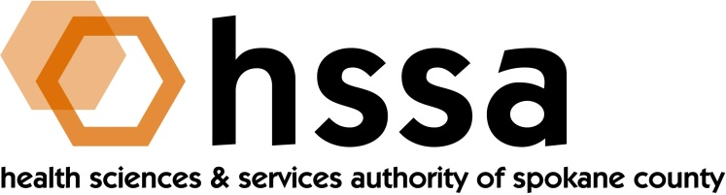

HSSA BOARD OF DIRECTORS

Minutes of the March 18, 2020 Special Board Meeting
Via Conference Call Due to Coronavirus Quarantine

Members Present: Nancy Isserlis, Board Chair; Mike Wilson, Grants Chair; Jason Thackston, Finance Chair; Daryll DeWald, Kevin Oldenburg, Dave Vachon and Frank Velázquez.

Members Absent: Darryl Potyk

Staff Present:

Susan Ashe, Executive Director; Laura McAloon, Attorney; Gaylene Lewin, Accountant

Guests:
None

- Call to Order
Nancy Isserlis welcomed everyone and called the meeting to order at what was considered a Special Board Meeting, and so noticed, due to the statewide coronavirus rule to stay home and not meet in groups.

- Board Actions
- Jason Thackston moved, and Mike Wilson seconded, approval of the December 18, 2019 Board Minutes that unanimously passed.
- Kevin Oldenburg moved, and Frank Velázquez seconded, a motion to approve HSSA Resolution 2020-1 adopting certain amendments to HSSA By-Laws. Unanimously passed

- Chair’s Report
Nancy Isserlis welcomed Allison Glasunow to the Board and had her provide a few brief comments of introduction. Board Chair Isserlis reported she had signed a series of warrants since the Board last met and when a warrant required two signatures, Board Members Jason Thackston or Dave Vachon provided. She also reminded he Board of the dates for quarterly meetings remaining in 2020 as June 17, September 16, and December 16. The Board was asked to mark their calendars accordingly.
The Chair introduced the subject of aid for local organizations on the frontline of providing critical services related to the COVID-19 pandemic. After much discussion, the Board agreed that this was an important role that fits within HSSA’s mandate and agreed that HSSA would provide up to $300,000. The Grants Committee and Executive Director were charged with quickly moving the process forward.

- Executive Director’s Report

The full Executive Director’s Report was included in the Board packet members received at the meeting.

Committee Reports

- Finance Committee
Jason Thackston, Finance Committee Chair, provided the Finance Committee report as of the end of February. HSSA overhead continues to remain below l0% threshold at 5.8%. State sales tax revenue remains strong, and collections are 5.8% greater than the two months ending in 2019.
The Board discussed a scenario that revenues could be/likely will be impacted by the coronavirus pandemic given business closures, and that HSSA revenues are entirely related to county-wide sales tax revenue collections. While we believe we should be fine cash-wise, but our Finance Committee and staff will carefully watch.
B. Grants Committee
The Grants Committee met on March 16, 2020 at 9:30 AM the HSSA office.
Attending were Grants Committee Chair Mike Wilson, and Grants Committee members Kevin Oldenburg, Dave Vachon, and Francisco Velázquez.
The Committee discussed additional information provided by Kim Johnson, about his proposal for a matching research grant for an “Automated Contingency Management System for the Reduction of Alcohol Use.” This project would demonstrate the capability of an end-to-end contingency management (CM) platform designed to reduce alcohol use in problematic drinkers. Focus is on behavioral modification strategies and process monitoring.
After discussion, the Committee determined it was not ready to submit to the HSSA Board at this time and would ask Johnson additional information and to resubmit his proposal with the additional information. Johnson requests a matching National Institute on Alcohol Abuse and Alcoholism $215,000 Phase I STTR grant.

- Counsel’s Report
There was no counsel report.

- Executive Session

The next regularly scheduled meeting of the HSSA Board is scheduled June 17, 2020,
3 PM, at Gonzaga University’s Hemmingson Center.

