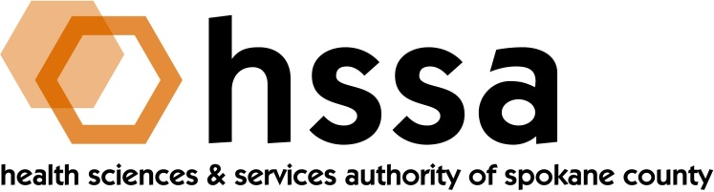

HSSA BOARD OF DIRECTORS

Minutes of the March 25, 2020 Special Board Meeting
Via Conference Call Due to Coronavirus Quarantine

Members Present: Nancy Isserlis, Board Chair; Mike Wilson, Grants Chair; Jason Thackston, Finance Chair; Daryll DeWald, Allison Glasunow, Kevin Oldenburg, Dave Vachon and Frank Velázquez.

Members Absent: Darryl Potyk

Staff Present:

Susan Ashe, Executive Director; Laura McAloon, Attorney

Guests:
None

Board Chair Nancy Isserlis welcomed everyone and called the conference call meeting to order at what was considered a Special Board Meeting, and so noticed, due to the statewide coronavirus rule to stay home and not meet in groups.

There was only one Agenda item for this Board meeting, and that was to hear a recommendation for funding HSSA’s grants to help fund COVID-19 impacts in Spokane County,

Mike Wilson, Grants Committee Chair, reported to the Board that nearly 40 proposals were received that totaled hundreds of thousands of dollars. recommended to the Board seven (7) grants to the following organizations:

The Guardian Foundation $ 12,000
Pioneer Human Services $ 18,000
The Salvation Army $ 30,000
Catholic Charities $ 40,000
Second Harvest $ 50,000
Innovia Foundation $ 50,000
Total $240,000

While there were many worthwhile proposals that spoke to the growing need locally, it was determined these organizations largely had a broader multiplier effect than did HSSA on its own. One organization needed immediate support to maintain operations.

The HSSA Board unanimously supported the recommendations for funding. The Executive
Director was taxed with immediate follow-up with the recipients, including payment, and follow-up with non-recipients in order for them to know their status.

The next regularly scheduled meeting of the HSSA Board is scheduled June 17, 2020,
3 PM, at Gonzaga University’s Hemmingson Center.

