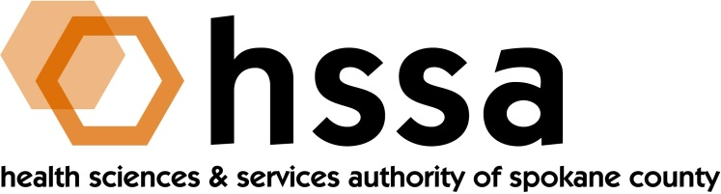

HSSA BOARD OF DIRECTORS

Minutes of the September 16, 2020 Board Meeting
Via Zoom Conference Call

Members Present: Nancy Isserlis, Board Chair; Mike Wilson, Grants Chair; Daryll DeWald, Allison Glasunow, Kevin Oldenburg, Darryl Potyk, Dave Vachon and Frank Velázquez.

Members Absent: Jason Thackston

Staff Present: Susan Ashe, Executive Director; Laura McAloon, Attorney; Gaylene Lewin, Accountant

Guests: Glenn Prestwich, Dr. Michelle Armstrong and April Needham, WSU sp3nw; JT Ramsey

- Call to Order
Nancy Isserlis welcomed everyone and called the meeting to order at 3:00 PM for our Board Meeting.

- Board Actions

- Dave Vachon made a motion, and Kevin Oldenburg seconded the motion, to approve he minutes of the July 14, 2020, Board meeting. The Board unanimously approved the motion.
- Frank Velázquez made a motion, and Darryl DeWald seconded the motion, to approve a new policy that allows the use of electronic signatures for Board members and staff. The Board unanimously approved the motion.
- Kevin Oldenburg moved and Mike Wilson approved to move $400,000 from the Administration budget to the Access to Care (15%) budget. The motion was unanimously approved by the Board.
- Kevin Oldenburg moved and Dave Vachon approved an Access to Care grant offering in 2020 of $150,000, and the Board unanimously approved.
- Kevin Oldenburg moved and Dave Vachon approved that earnings of $1,500,626 ,and fees and interest of $2,346,387, in the “Other” column related to a Board discussion about the Estimated Funds for Grants Available be allocated proportionately across three categories of funds including Research, Access to Care, and Administration. The motion was unanimously approved by the Board.

- Chair’s Report
The Chair called the meeting to order at approximately 3 PM. In addition, the Chair sought the approval of the July 14, 2020 Board Minutes, which she received. She also asked Board members to provide any updates they might have to share.

- Executive Director’s Report
The full Executive Director’s Report was included in the Board packet members received in an email prior to the meeting.

- Finance Committee Report
Gaylene Lewin, consulting Accountant, gave the Finance Committee’s report in the Committee Chair’s absence. HSSA’s overhead remains below 10% at 7.1%. There was a slight increase in State Sales Tax Remittance through July 2020, although the County is estimating an approximate 3.5% drop for the year related to the coronavirus pandemic.
The Board did say it would appreciate a cash flow analysis.

- Grants Committee Report

Grants Committee Chair Wilson asked Gaylene to review with the Board a document she had prepared at the Executive Director’s request called the Estimated Funds for Grants Available, which she did. The Board had a discussion from which a number of decisions were made as shown in the Board Actions portion of this report to include Items c, d and e.

One of the decisions was to have the Executive Director move forward the annual Access to Care grant award program for a total amount of grants of $150,000.This is in addition to the $240,000 HSSA spent earlier in the year for Covid-19 relief in the County.

- Legal Report

Attorney Laura McAloon introduced a Policy approving electronic signatures by Board Officers, Members and Staff. A motion put forward to the entire Board was unanimously passed

McAloon and the Executive Director brought forward for the Board’s information and potential future action the matter of Spokane County’s refinancing of HSSA’s 2010 bond without notice. After much discussion, it was concluded that the Board Chair, Attorney, Executive Director and Accountant will proceed by requesting a meeting with County representatives to better understand the matter before any action by the Board, and will report the results of the meeting to the full Board.

- Other Business
Frank Velázquez introduced a proposal to the Board from the Life Science Washington Institute for funding of $12,500 for two SBIR/STTR virtual workshops. The Executive Director will send the proposal to Board members.

- Adjournment
The Chair adjourned the meeting at approximately 4:40 PM.

The next regularly scheduled meeting of the HSSA Board is scheduled December 16, 2020,
via Zoom conference call.

