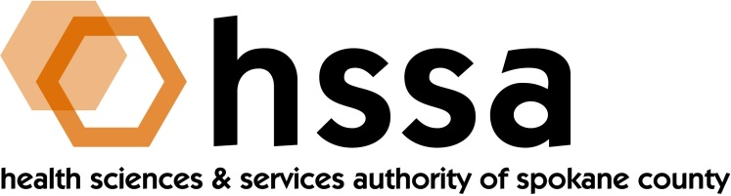

HSSA BOARD OF DIRECTORS

Minutes of December 15, 2021
Via Zoom Conference Call – 3 PM

Members Present: Jason Thackston, Board Chair; Mike Wilson, Grants Chair; Carla Cicero, Daryll DeWald, Kevin Oldenburg, Darryl Potyk, Dave Vachon and Frank Velázquez.

Members Absent: Darryl Potyk, Allison Glasunow

Staff Present: Susan Ashe, Executive Director; Kendel Froese, Consulting Attorney; Gaylene Lewin, Consulting Accountant

Guests: None

- Call to Order
Jason Thackston, Board Chair, welcomed everyone and called the meeting to order at about 3:00 PM.

- Board Actions

- Frank Velázquez made a motion to approve the September 15, 2021 Board meeting minutes, and Daryll DeWald seconded the motion. The Board unanimously approved the minutes. [The date should have read October 12, 2021 as the September Board meeting was moved to the October date].
- Mike Wilson moved and Kevin Oldenburg seconded a motion to accept a Grants Committee’s recommendation. The motion passed unanimously.
HSSA had announced up to $325,000 available to fund these grants. About $654,000 in requests were received.
- Partners with Children & Families $ 85,000
Children’s Advocacy Center (CAC)

- Spokane Prescription Assistance Network 30,000

- Providence Health Care Foundation 86,865
to fund a mid-level primary family nurse for
Homeless Adolescents for one year.

- Pioneer Human Services 20,000
Pioneer Center East to address mounting
substance abuse crisis in Spokane County which
has twice the methamphetamine-involved overdose
deaths as King County with five times more populace.

- Daybreak Youth Services 23,000
Help fund a Restorative Receiving Center for
Sexually-exploited youth who are victims of sex
Trafficking, childhood prostitution and other related
crimes perpetrated upon them.

- CHAS (Community Health Association of 50,000
Spokane) “Street Medicine” program to provide
health care to people where they reside on the
streets and locations frequented by the homeless.

- Spokane Regional Domestic Violence Coalition 30,000
to fund expansion to 13 school districts the SRDVC
Handle with Care education program.
TOTAL $324,865

- Mike Wilson proposed and Dave Vachon seconded, a motion to appoint Kevin Oldenburg to serve as HSSA Grants Chair, replacing Mike Wilson who has served in this role for several year and is retiring from the HSSA Board.
- Kevin Oldenburg moved and Carla Cicero seconded a motion to approve HSSA’s 2022 operating budget of $197,500.

- Board Chair’s Report
In addition to working through the meeting actions to accommodate timing needs of some
Board members, Jason Thackston also announced to the full Board that Gaylene Lewin, the organization’s long-time consulting accountant will retire at the end of the year. He sincerely thanked Gaylene for her outstanding service to HSSA, and attributed the organization’s successful state audits in large part to her. Gaylene agreed to work with Susan to help identify a replacement and provide support to the new person.

- Adjournment
The meeting was adjourned at 3:35 PM.

PLEASE MARK YOUR CALENDARS for 2022 Meeting Dates:
March 16, 2022
June 15, 2022
September 21, 2022
December 21, 2022

(The HSSA Board reserves the right to change a meeting date with proper notice).

