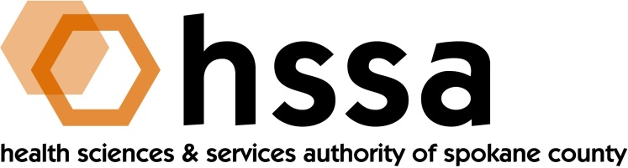

HSSA BOARD OF DIRECTORS

Minutes of the March 17, 2021 Board Meeting
Via Zoom Conference Call

Members Present: Jason Thackston, Board Chair; Mike Wilson, Grants Chair; Daryll DeWald, Allison Glasunow, Kevin Oldenburg, Darryl Potyk, Dave Vachon and Frank Velázquez.

Members Absent: None

Staff Present: Susan Ashe, Executive Director; Laura McAloon, Attorney; Gaylene Lewin, Accountant; Kendel Froese, Attorney

Guests: Lars Gilberts, University District CEO; Michaela Armstrong, Assistant Director, sp3nw

- Call to Order
Jason Thackston welcomed everyone and called the meeting to order at about 3:00 PM for the Board Meeting.

- Board Actions

- Kevin Oldenburg made a motion to approve the February 10, 2021 Special Board meeting minutes, and Mike Wilson seconded the motion. The Board unanimously approved it.
- Dave Vachon moved to accept the Amended 2021 HSSA Budget, and Mike Wilson seconded the motion which was unanimously approved by the Board.
- Kevin Oldenburg moved and Frank Velázquez seconded the nomination of Board Member Allison Glasunow as Board Finance Chair. The Board unanimously supported the motion.
- Chair’s Report
Chair Jason Thackston called the meeting to order at approximately 3 PM. In addition, the Chair sought the approval of the February 10, 2021 Board Minutes, which he received.

Thackston also reported that through a good team effort, HSSA and Spokane County reached resolution of HSSA’s desire to pay off its loan debt related to the 2010 bond that provided initial upfront funds for HSSA’s use. The total savings to HSSA was $76,000. The payoff amount was $2,107,166. The remaining interest from the 2010D bond was $150,000 and the two parties agreed to split the money 50-50. This action also freed up $500,000 to HSSA that had been held in a fund if ever required to help HSSA make its bond loan payment, which never occurred. Three HSSA funds held in the County’s investment pool (SCIP) will be deleted, leaving one fund 661 for all HSSA matters.
The Chair introduced Lars Gilberts, CEO of The University District in Spokane. Lars also serves as chair the UDDPA Board of Directors. Gilberts presented an excellent update about the University District, acknowledging the new South Landing Catalyst and Scott Morris energy-focused buildings where experiments can occur and how the interdisciplinary efforts also drive health solutions. The intent is for research that drives economic growth for all people. He said the UD has encouraged housing in the district and noted that there are over 600 units of housing under construction in/near the District. Sprague Avenue upgrades will conclude in 2021 and the Trent Bridge project concludes in 2022.

Gilberts said planning is underway to welcome everyone back to the University District post pandemic and university and business closures, parking solutions identified and addressed, MultiCare’s fun run in the District, perhaps some ways to highlight research/researchers and HSSA’s presence during events, and other activities. He sees the District needing more lab space, more innovation space, sees partnerships as a way of accomplishing, etc.

- Executive Director’s Report
The full Executive Director’s Report was included in the Board packet members received in an email prior to the meeting. She did remind Board members of the upcoming 2021 Life Science Washington Innovation NW (#LSINW) conference to be held online March 30-31, and that HSSA is a co-sponsor with GSI.

- Finance Committee Report
Gaylene Lewin reported the Finance Committee report on behalf of former chair Thackston of this committee and the incoming chair Glasunow. She reported that separate from the financial report, members had an Amended 2021 Budget for action in their packets that simply reflected a change in interest income given the bond load debt payoff.

She reported that budget overhead remains below 10% at 7.2%; HSSA had a 4% ($17,428) gain in sales tax collections Jan-Feb 2021 to the same period in 2020. She reviewed the changes related to the early pay off of the bond debt to Spokane County in terms of savings to HSSA and that the loan balance will no longer appear on our financial reports, and a change in interest expense.

- Grants Committee Report

There was no Grants Committee report.

- Legal Report

Counselor Laura McAloon will prepare for HSSA’s June meeting a Resolution asking the Board of County Commissioners to continue to transfer .02 percent County-wide sales tax to HSSA on a monthly schedule after 2022 for 15 years. This is related to HSSA’s reauthorization 2023-2038.

- Other Business

There was no other business.

- Adjournment
The Chair adjourned the meeting at approximately 4:30 PM.

The next regularly scheduled meeting of the HSSA Board is scheduled June 16, 2021,
the location to be determined or by Zoom.

