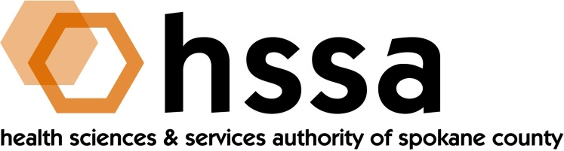

HSSA BOARD OF DIRECTORS

Minutes of October 12, 2021 Special Board Meeting
Via Zoom Conference Call – 8 AM

Members Present: Jason Thackston, Board Chair; Mike Wilson, Grants Chair; Allison Glasunow, Board Treasurer; Carla Cicero, Daryll DeWald, Kevin Oldenburg, Darryl Potyk, Dave Vachon and Frank Velázquez.

Members Absent: None

Staff Present: Susan Ashe, Executive Director; Kendel Froese, Consulting Attorney; Gaylene Lewin, Consulting Accountant

Guests: None

- Call to Order
Jason Thackston, Board Chair, welcomed everyone and called the meeting to order at about 8:00 AM.

- Board Actions

- Kevin Oldenburg made a motion to approve the June 16, 2021 Board meeting minutes, and Mike Wilson seconded the motion. The Board unanimously approved the minutes.
- Mike Wilson moved and Daryll DeWald seconded a motion to accept a Grants Committee proposal to raise the maximum limit of research grants above the $1 million limit for individual applicants for research grants under certain conditions and when the applicant has reached a point of predictable success that has been made convincingly clear to HSSA. The motion was unanimously approved.
  - The subject research has been funded, in part, by HSSA;
  - The applicant has commercialized a product or is close to commercializing a product, therapy or treatment;
  - The applicant is ready to sell or has started marketing the product for sale, therapy or treatment; or
  - The applicant has received outside investment.

The applicant remains subject to the HSSA’s Grant Payback language as found in Article 31 of the organizations Grant Award Agreement, which states:

“It is the intent of the HSSA to recover taxpayer money upon the successful completion of any of the options listed here in Article 31 in order to reinvest these funds in new grants.
If, at any time, Grantee assigns, sells, licenses or otherwise surrenders or transfers all or any part of Grantee’s rights and/or ownership interests in any discovery, material, method, process, product, program, software, business or use, whether patented or patentable, copyrighted or copyrightable, conceived or made in the course of performing the activities set forth in this Agreement, Grantee shall be immediately liable to Grantor for the repayment of the Grant, in full, to the Grantor. The terms and conditions of such repayment shall be negotiated in good faith by the parties. All of the terms, covenants and conditions of this Article 31 will be binding upon and inure to the benefit or liability of each of the parties hereto and their successors and assigns. The payment of any and all grant funds to Grantee is expressly conditioned upon Grantee’s acceptance of any and all repayment obligations under this Article 31.”
Grantee Initials:

__XC__
The applicant remains subject to reporting requirements and all other requirements found in the HSSA Grant Award Agreement signed by both parties.
- Mike Wilson proposed and Frank Velázquez seconded, a motion recommended by the Grants Committee to fund an $85,000 matching translational grant to Dr. Hashena Hosseinabad for use of ultrasound as biofeedback during articulation therapy for children with cleft palate. The motion was unanimously passed.
- Mike Wilson proposed and Kevin Oldenburg seconded a motion to fund the 2022 Access to Care Grants program for up to $325,000.

- Adjournment
The meeting was adjourned at approximately 8:30 AM.

PLEASE MARK YOUR CALENDARS: The final regularly scheduled meeting of 2021 of the HSSA Board is scheduled December 15, 2021. It is hoped the Board will be able to meet in-person, location to be determined.

