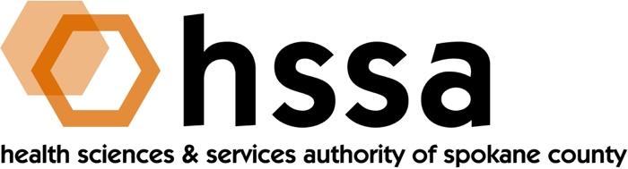

HSSA BOARD MEETING
Wednesday, June 15, 2022 – 3:00 PM
WSU Academic Building, Conference Room 501

AGENDA

- Welcome – Jason Thackston, Board Chair (:05 min.)
- Establish Quorum, Confirm Agenda

- Action Items
- Approve March 16, 2022 Board Minutes Action Required
- Approve Grant Committee Recommendations Action Required
- Other

- Board Chair’s Report (:40 min.)
- Quorum established
- Have guests introduce themselves
- Possible brief presentation and funding request for partial
funding for a JLL survey of life science in Spokane ecosystem
- HSSA Executive Director Retirement & Search Committee
Discussion
- HSSA Strategic Planning Discussion (once new ED is appointed)
- Board Meetings Reminder – Sept. 21 & December 21, 2022

- Executive Director’s Report (In packet)

- Finance Committee Report –Allison (05 - 10 min.)
A. Financial Report

- Grants Committee Report –Kevin Oldenburg (10 min.)
- The Grants Committee met by phone of April 18, 2022 and
Makes the following recommendation(s) to the full HSSA Board:
- Recommends funding Iasis Molecular Sciences a matching grant
for $450,000
- Recommends 2nd Sight Bioscience’s request for a
one-month extension of its current extension, at no cost

- Other
- Recommends funding $10,000 for Spokane Regional Health District for partial/shared funding of its annual Quality of Life Survey. The survey results are utilized by healthcare providers, and others to determine gap in service needs. It is also used by non-profit organizations and foundations to determine efforts that would address specific populations needs and areas in which overall health and wellness can be positively impacted by research, education and service coordination or expansion.

- Recommends passing Amendment No. 1 to HSSA Grant Award dated January 7, 2022, to Dr. Hashena Hosseinabad at Eastern Washington University to partially fund ($24,512) equipment to complete the original research “Ultrasound Biofeedback During Articulation Therapy for Children with Cleft Palate.”

- Legal Report

- Executive Session (only if necessary)

- PUBLIC COMMENTS

- Adjournment

The next meeting of the HSSA Board is Wednesday, September 21, 2022, a 3 PM. Location to be determined.

