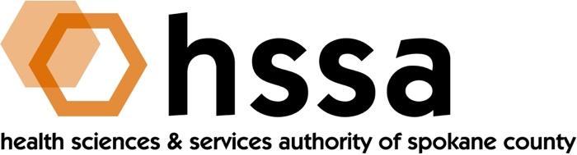

HSSA SPECIAL BOARD MEETING
Monday, October 31, 2022 – 11 AM via Zoom

The Health Sciences and Services Authority (HSSA) Board of Directors has announced a Special Board Meeting to be held Monday, October 31, 2022 via Zoom.

The sole purpose of this meeting is to appoint a new Executive Director.

If you wish to participate, please contact HSSA at susan@hssaspokane.org or call 509.995.8356.

Thank you.

