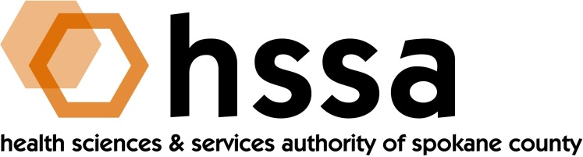

HSSA BOARD OF DIRECTORS MINUTES

October 26, 2022
GU Hemmingson Center, HEMM 316 (Loyola Dining Room)

Members Present: Jason Thackston, Board Chair; Kevin Oldenburg, Grants Chair; Alex Jackson, Alison Poulsen, Darryl Potyk (via Zoom), Dave Vachon and Frank Velázquez

Members Absent: Daryll DeWald, Allison Glasunow

Staff Present: Susan Ashe, Executive Director; Thad O’Sullivan, Consulting Attorney; Gaylene Lewin, Consulting Accountant

Guests: Allison Beason, Life Sciences & Global Health Sector Lead, Washington State Department of Commerce

- Call to Order
Jason Thackston, Board Chair, established a quorum, invited guests to introduce themselves, welcomed new Board Members Alison Poulsen, who leads Better Health Together, recently appointed by Governor Inslee, and called the meeting to order at about 3:05 PM.

- Board Actions

- Kevin Oldenburg made a motion to approve the Board meeting minutes, from June 15, August 10 and Sept. 29, 2022, and Frank Velázquez seconded the motion. The Board approved the December minutes with one abstention, Alison Poulsen who was not a member at the time.

- Kevin Oldenburg, on behalf of the Grants Committee, recommended funding of up to $65,000 for equipment for WSU’s SP3NWto purchase equipment to create a BSL1 lab based on community need. HSSA reserves the right to review the final equipment list considered for purchase. Dave Vachon seconded and the motion passed unanimously.

- Board Chair’s Report
The Chair asked and received approval of the Board minutes from the June 15, August 10 and Sept. 29, 2022 meetings. Kevin Oldenburg moved to approve and Frank Velázquez seconded the motion which passed with one abstention from Alison Poulsen on the Board at the time.

Jason reported that during the interim he signed warrants and where necessary, Dave Vachon provided a second signature, for which Jason thanked him.

The Chair said that he continues to want to held a strategic planning effort and suggested this occur after the new Executive Director is on board January 1, 2023. He also informed the Board that he and staff will provide any needed update to the 2022 budget and a proposed 2023 budget at the December Board meeting. He suggested December 14th but asked the Executive Director to again query Board members about this date and a few additional options.

Jason said that was not a name to put forward for today’s Executive Session so moved forward with the regular business of the Board until later in the meeting.

He welcomed guest Allison Beason, Life Sciences and Global Health Sector Lead for the
Washington State Department of Commerce, and invited her to introduce herself. Allison brings a wealth of experience from a few decades in Washington D.C with NIH and other federal agencies and advised the President’s life sciences recommendation. Allison is originally from western Washington and returned home several months ago. She has been to Spokane and intrigued with all that’s going on here and visits regularly as she introduces herself and sector around the state.

- Executive Director’s Report
The Executive Director referred Board members to their packets for the written report and highlighted key upcoming events. Susan said that since the annual Access to Care grant program totaling $475,000 closed Oct. 24th for applicants, HSSA received 14 requests with total combined requests of over $1.3 million, which portends a lot of work by the Grants
Committee in the near term, and also mentioned several upcoming events.

- Finance Committee Report
Finance Chair Allison Glasunow was traveling, so Susan and Gaylene Lewin reported the following update:
- Operating expenses remained below 10% largely due to the pandemic
- From its inception through Sept. 30, 2022, HSSA has received $28,531,830 in Washington State tax collections. HSSA has awarded nearly $14 million in grants. For various reasons, $757,349 has been returned, and $1,458,451 remains to be paid as directed in the grant award agreements with recipients.

- Grants Committee Report

- Legal Report
There was no legal report.

- Executive Session
Jason Thackston opened the Executive Session at 3:40 PM, and adjourned it at 4:10 PM

- Adjournment
The October 26th Board meeting was adjourned at 4:15 PM.

PLEASE MARK YOUR CALENDARS for REMAINING 2022 Meeting Dates:

- The HSSA will hold a Special Board Meeting on Monday, Oct. 31, 2022 at 11 AM, the sole purpose of which is to vote on a new Executive Director.
- Election Day Tuesday, November 8, 2022 – VOTE.
- GSI 25th Annual Economic Forecast, Nov. 15th, 7-9 AM, Spokane Convention Center
- GSI Annual Legislative Reception, Dec. 7th, 3:30=7 PM, Fox Theater
- HSSA December 2022, Board Meeting, date TBD.

(The HSSA Board reserves the right to change a meeting date with proper notice).

