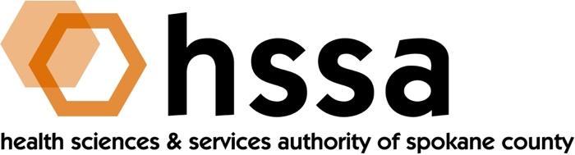

HSSA BOARD MEETING
Wednesday, October 26, 2022 – 3:00 PM
Gonzaga University, Hemmingson Center (HEMM 316)

AGENDA

- Welcome – Jason Thackston, Board Chair (:05 min.)
- Establish Quorum, Confirm Agenda

- Action Items
- Approve June 15, August 10 & Sept. 29, 2022 Board Minutes Action Required
- Approve Grant Committee Recommendations Action Required
- Approve Executive Director Action Required
- Other

- Executive Session – Jason (:20 min.)
- Personnel matters

- Board Chair’s Report (:40 min.)
- Quorum established
- Have guests introduce themselves
- Alison Beeson, Life Sciences Sector Lead, WA Department of Commerce
- Board Meeting Reminder –December 21, 2022
- HSSA Strategic Planning
- Personnel matters

- Re-start Board Meeting

- Executive Director’s Report (In packet)

- Finance Committee Report –Allison Glasunow (10 min.)
A. Financial Report

- Grants Committee Report –Kevin Oldenburg (10 min
- Grants Report

- Legal Report – Thad O’Sullivan

- PUBLIC COMMENTS

- Adjournment

The next meeting of the HSSA Board is a Special Board Meeting on Monday. Oct. 31, 2022 at 11 AM via Zoom. The final meeting of the Board will be in December, date to be determined.

