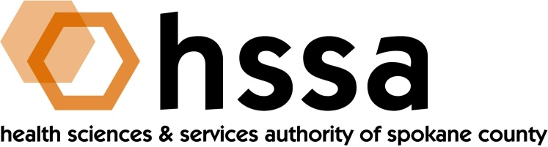

HSSA BOARD OF DIRECTORS
Minutes of the September 19, 2018 Board Meeting

Members Present: Mike Wilson, Grants Committee Chair; Scott Gordon, Gary Pollack, Darryl Potyk, Jason Thackston and Frank Velázquez

Members Absent:
Nancy Isserlis
Kevin Oldenburg
Dave Vachon

Staff Present:
Susan Ashe, Executive Director

Guests:
Megan Hulsey, Director, StartUp Spokane

- Call to Order
Mike Wilson welcomed everyone and called the meeting to order at approximately 3 PM. The meeting was held at the Hemmingson Center, Manresa Room 314A at Gonzaga University.

- Board Actions
- Gary Pollack moved, and Jason Thackston seconded, a motion to approve the meeting minutes from the May 16, 2018 Board meeting. The motion passed unanimously.
- Jason Thackston moved, and Scott Gordon seconded, a motion to approve issuance of the annual HSSA 2019 Access to Care $300,000 competitive grant.

- Chair’s Report
Mike reported that the Board Chair had signed a series of warrants since the Board last met on May 16, 2018, and when a warrant required two signatures these were provided by Jason Thackston, HSSA Finance Chair.

Megan Hulsey, Director of StartUp Spokane was introduced by the Executive Director. Megan is he person who sets the direction and annual program for StartUp Spokane, an organization under the auspices of Greater Spokane Incorporated. Megan has a BA in Political Science and International Relations from Willamette University and a BS in Chemistry from Eastern Washington University. Megan said that since its inception, StartUp Spokane has assisted more than 700 entrepreneurs, created approximately 875 jobs with an estimated economic impact of more than $39 million. Megan conducts one-on-one consultations with entrepreneurs, and she has conducted over 230 in 2018 alone to date. She also manages applicants for the Mind to Market Incubator, which is a pre-seed funding program. She has recommended several medical/health sciences start-ups to HSSA for potential grant-writing funding and will continue to do so.

- Executive Director’s Report
The Executive Director’s Report was included in the Board packet members received at the meeting.

- Committee Reports

- Finance Committee
Jason Thackston, Finance Committee Chair, provided the Finance Committee report. All looks good and HSSA continues to remain below l0% threshold at 7.9%. State sales tax and earnings om funds are higher than we budgeted, which is always good news. year to date is $684,902. There is an unanticipated request for a financial audit of the organization sometime in 2018 because annual revenue in 2017 was over $2 million, and while not budgeted, HSSA will comply.
B. Grants Committee
Mike Wilson, Grants Committee Chair, reported on the Access to Care grant RFP having issued on August 29th for up to $300,000. He recommended that the Board formally vote to approve this action “nunc pro tunc.” Jason Thackston moved to approve and Scott Gordon seconded the motion, which was approved unanimously. There will be a need for a Grants Committee meeting before the December 19th Board meeting to review proposals from this grant.

Mike provided a report on three grants made from the re-funded Small Grant-Writing consultant support grant. They are Medicurity, Inc.. a small company developing a platform agnostic assessment tool with embedded guidance to help providers meet HIPPA risk assessment requirements; and two grants to Shobhan Gaddameedhi, Ph.D. from the WSU College of Pharmacy. Dr. Gaddameedhi has two lines of research he is pursuing. One relates to skin cancer during shift work and the body’s endogenous circadian clock. The second line of research attempts to minimize skin and heart toxicity due to radiation used on breast cancer by harnessing the circadian clock during radiation treatment. A fourth grant from Photo Biosciences has not been made, as reported, as HSSA is waiting for the company to move to Spokane from Pullman.

A discussion was had by Board members on an inquiry from Whitworth University as whether it should apply for $148,866 to be combined with $325,000 received from the National Science Foundation to purchase a Multi-use Single Crystal X-Ray Diffractometer to be shared with other local universities (EWU, Gonzaga and WSU), among other universities. The members asked the Executive Director to seek additional information.

The Board also heard a brief report from Frank, who is currently serving as the Executive Director of the Life Science Washington Institute in Seattle. Frank has approached his Board and been approved to provide these same services in Spokane. It is preliminary but could coincide with HSSA’s consideration of investment in a health science incubator setting.

Mike Wilson asked Frank to bring a report and/or proposal to HSSA at its December meeting.

- Counsel’s Report
There was no report.

The meeting was adjourned at approximately 4:20 PM by Mike Wilson.

The next meeting of the HSSA Board is scheduled December 19, 2018, 3 PM, location TBD.

